Name: Date:

**Can You Tell Time?**

C:\Users\bwkirk\AppData\Local\Microsoft\Windows\Temporary Internet Files\Content.IE5\SX9RPENB\MC900440524[1].wmfPlease fill in the correct time in the space provided. After you are finished, you may add clipart beside every clock that demonstrates what you are doing at that time. The first has been done for you as an example.

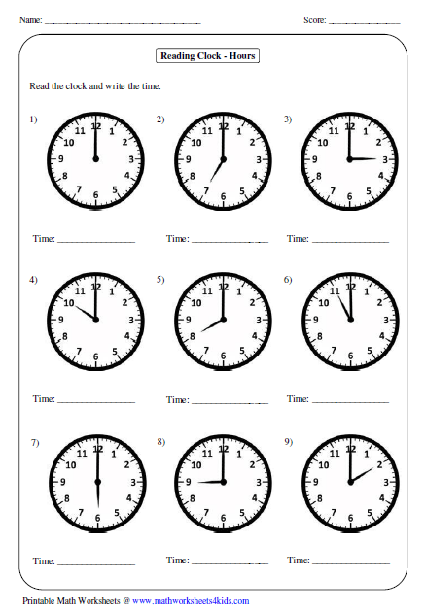

12:00 pm

12

: pm

: am

: pm

: am

: pm

: am

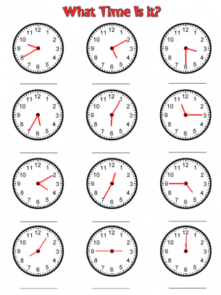

: pm

: am

: pm

: am

: pm

: am

: pm

: am