Lesson Plan Guide

Teacher Candidate: Brittney Kirk Date: 04/22/14 ______
Grade and Topic: Kindergarten, Science Length of Lesson: 1 hour ______
Mentor Teacher: Dr. Carmen Weaver School: University of Memphis

UNIT/CHAPTER OBJECTIVE/GENERALIZATION/BIG IDEA:
- The animal and offspring lesson helps students to realize that baby animals resemble their parents. This lesson requires students to look at a website to discover all types of baby/parent pairs and create a similar chart in Word. They also must play an interactive game to match different offspring to their mothers as described in TN state science standard 4.

LESSON OBJECTIVE:

Content Learning Goals and Objectives
- Given a website about animal offspring and parents, the student will look at information about the names of animals, the female name, male name, offspring name, and group name with 3 out of 3 on the rubric.
- Given a handout, students will record information about their favorite five animals from the chart with 3 out of 3 on the rubric.
- Given Word software, students will recreate the chart on the handout onto Word with at least 2 out of 3 on the rubric.
- Given clipart, students will add pictures into their chart to show similarities in the mother and offspring with at least 2 out of 3 on the rubric.

Student Participation
The goal of this lesson is for students to demonstrate an understanding that animal offspring
resemble their parents. Students use internet, handouts, Word software, and clipart to
demonstrate their understanding.

STANDARDS ADDRESSED:

State/ District, Common Core Standards
TN Science- 0007.4.2 Observe that offspring resemble their parents.
Match pictures of seedlings to adult plant and a juvenile to the adult animal.

ISTE Standard(s)
- Standard 3- Research and Information Fluency- Students apply digital tools to gather, evaluate, and use information
- Standard 4- Critical Thinking, Problem Solving, and Decision Making- Students use critical thinking skills to plan and conduct research, manage projects, solve problems, and make informed decisions using appropriate digital tools and resources
- Standard 6- Technology Operations and Concepts- Students demonstrate a sound understanding of technology concepts, systems, and operations.

MATERIALS:

Materials Used
- Handout to fill out
- Computer
- Internet Access
    - MS Clipart Gallery http://office.microsoft.com/clipart/default.aspx?lc=en-us
    - http://www.enchantedlearning.com/subjects/animals/Animalbabies.shtml
- Microsoft Word
- Pencil

Technology Integration
Students will use the clipart gallery website in order to find pictures that illustrate the offspring
and the parent. Students will use Word processing software to type, format a table, and add
images in the correct columns based off of the handout given to them. After completing the table
accurately, the students will save their work to the computer and print the document out for the
teacher to receive. A sample of the final product is located on the last page.

BACKGROUND and RATIONALE:
- Students will demonstrate an understanding that offspring resemble their parents.
- Students will record information onto a handout and then reproduce the table in Word.
- This lesson is a continuation of TN science standard 4.
- Academic Language is not addressed in IDT 3600.
- This lesson builds off of the other lessons from the past week where we learned about animal names and sounds. We also learned about classifying similar animals into groups. We also discussed animal’s and their offspring (how they relate, how they look alike, how the offspring changes over time, etc.).
- We will refer to the summary created here as we continue to learn about animals and offspring.
- I am aware that the lesson will be differentiated for students who did not master the objectives and for those ready for enrichment. However, the modifications are not covered in this course and are not part of this particular lesson.

PROCEDURES AND TIMELINE:
- Introduction:
- Begin by reviewing things that were learned throughout the week.
  - Ask questions like:
    - Who can tell me what an offspring is?
    - Who can tell me what a cat’s offspring is called?
    - What is something else that you remember learning from this week?
    - Etc.
- Review the song that we learned earlier in the week. Have students sing the song with me.
  - Chickens have chicks, Rabbits have bunnies, Dogs have puppies, They are cute and they are funny, Cats have kittens, A cow has a calf, A bear has a cub, Baby animals make us laugh.

- Procedures:

Prior to the Computer (5 minutes)

Teacher Procedures:  After the introduction, explain to students what it is that they are going to be doing. They will be visiting a website to gain information about different animals and their offspring. They will fill out a handout and then recreate the handout in Word. Then, pass out the handouts that the students will fill out. | Student Procedures:  Students listen quietly to the directions given. They sit quietly at their computers while waiting to get their handout.

At the Computer (45 minutes)

Teacher Procedures:  - Help students get to the correct website.  - Explain to students what each column means on the website.  - Help students open Word when they are ready.  - Help students create a table if they need.  - Help students find clipart.  - Walk around and help as needed. | Student Procedures:  - Student visits the correct website to learn new information.  - After looking over the entire page, students pick their five favorite animals.  - Student fills in their handout based off of the information that they find about their five favorite animals.  - Students open Word to recreate their table.  - Click File, Save as, and save document as “Animal and Offspring”  - Student will click Insert, Header, choose the blank one, and then add their name there.  - Student will exit header.  - Students will center text and type “Animals and Offspring”.  - Students click Insert, Table, and adds a 7 x 6 table.  - Students will follow the handout to type the headings- “Animal Name, Picture, Male, Female, Baby, Picture, Group”  - Students will then bold the title text.  - Students will begin filling in the information in the table based off of their handout that they filled out.  - Student should save after each set of information they add.  - Student will add appropriate clipart in each of the picture columns- one for parent and one for offspring.  - When student has finished the table, the student should save one last time and then print.

After the Computer (10 minutes)

Teacher Procedures:  - Have students join circle time.  - Call out students name to come to the front to tell about one animal that they wrote about. | Student Procedures:  - Student will present their information about one animal.  - Student will listen quietly when other students are going.

- Closure:
Go over several different types of parents and offspring. Review what each column meant and explain further. Relate this back to our lives by explaining that we are our parent’s offspring, and we often sometimes resemble our parents. Ask if students have any questions.

ASSESSMENT EVIDENCE:

Animal and Offspring Rubric
Criteria | 0 | 1 | 2 | 3
Look at information on the website | Student did not look at the website. | Student looked at information but would not sit still or be quiet. | Student looked at information but seemed distracted. | Student did a great job of looking at the information.
Pick 5 favorite animals | Student did not pick any animals. | Student only picked 1-2 animals. | Student only picked 3-4 animals. | Student picked five animals.
Fill out the handout | Student did not fill out handout. | Student filled out a small amount of the handout. | Student filled out majority of the handout. | Student filled out the handout correctly.
Create the handout in Word | Student did not create table in Word. | Student attempted to create a handout in Word. | Student created majority of the handout in Word. | Student created the correct document in Word.
Add appropriate clip art | Student did not add clipart. | Student added clipart, but it did not make sense or only added appropriate clipart to a few of the sections. | Student added appropriate clipart to most of the sections. | Student added appropriate clipart in all sections.
Print the document | Student did not print. | N/A | N/A | Student did print.

MODIFICATIONS:
I am aware that modifications will be made for students who did not master the objectives and for those ready for enrichment. However, modifications are not covered in this course and are not part of this particular lesson.
STUDENT SAMPLE:
Animal | Picture | Male | Female | Offspring | Picture | Group
Cat | 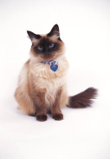 | Tomcat | Queen | Kitten | 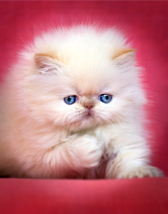 | Clutter, clowder, litter, kindle
Deer | 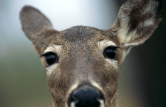 | Buck, stag | Doe | Fawn | 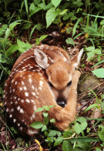 | Herd, mob
Dolphin | 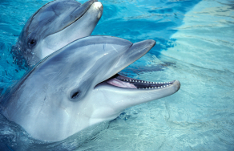 | Bull | Cow | Pup, calf | 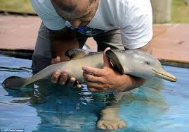 | Herd, pod, school
Lion | 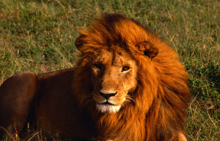 | Lion | Lioness | Cub | 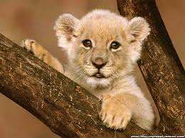 | Pride
Squirrel | 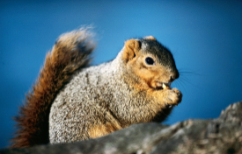 | Buck | Doe | Pup, kit, kitten | 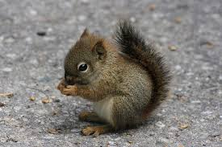 | Dray

